**ADDITIONAL MATERIALS (WORK CARDS, PICTURES, RECORDINGS)**

Attachment 1:

**Energy sources:**

* nuclear fission
* nuclear fusion
* solar energy
* wind energy
* fossil fuels
* hydroelectric energy
* tidal energy
* geothermal energy
* biomass
* hydrogen fuel

Attachment 2:

**Which energy sources use the following objects?**

1. solar energy
2. wind energy
3. hydroelectric energy
4. nuclear fission
5. hydrogen fuel
6. tidal energy
7. fossil fuels

____ dam

____ waves

____ mills

____ coal

____ fuel cell

____ reactor

____ photovoltaic (PV) panels

____ uranium

____ oil

**KEY:**

solar energy – photovoltaic (PV) panels

wind energy – mills

hydroelectric energy – dam

nuclear fission – reactor, uranium

hydrogen fuel – fuel cell

tidal energy – waves

fossil fuels – coal, oil

Attachment 3:

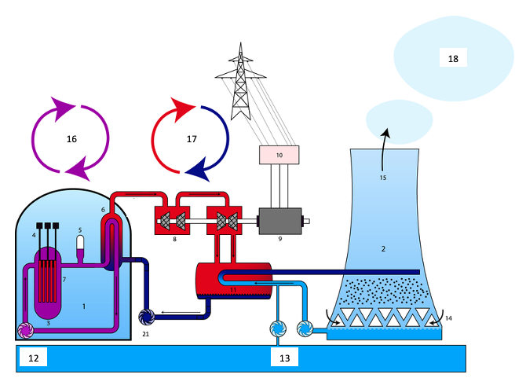

Design of a nuclear power plant with a pressurized water reactor (PWR)

1. reactor block
2. cooling tower
3. reactor
4. control rod
5. support for pressure
6. steam generator
7. fuel element
8. turbine
9. generator
10. transformer
11. condenser
12. river
13. cooling-water circulation
14. air
15. air (humid)
16. primary circuit
17. secondary circuit
18. water vapor
19. pump

**source:** [**https://commons.wikimedia.org**](https://commons.wikimedia.org)

Attachment 4:

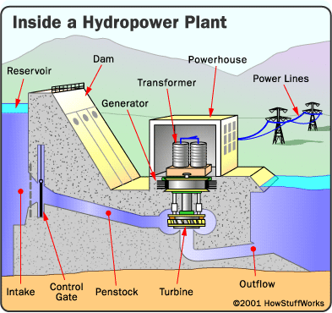

**source:** [**https://cz.pinterest.com**](https://cz.pinterest.com)

Attachment 5:

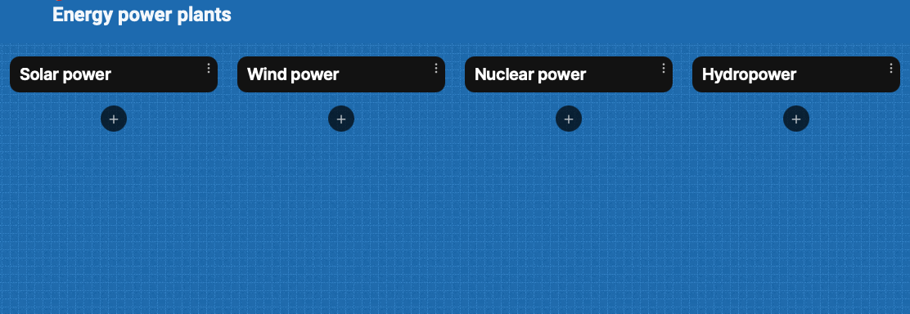

Attachment 6 (source: Čepičková, J., *English for Mechanical Engineers 5*):

**Advantages and disadvantages of wind energy**

1. Wind is free and it can be captured efficiently with modern technology.
2. Once the wind turbine is built, the energy it produces does not cause greenhouse gases or other pollutants.
3. Although wind turbines can be very tall, each takes up only a small plot of land. This means that the land below can still be used. This is especially the case in agricultural areas, as farming can continue.
4. Many people find wind farms an interesting feature of the landscape.
5. Remote areas that are not connected to the electricity power grid can use wind turbines to produce their own supply.
6. Wind turbines have a role to play in both the developed and the developing world. Wind turbines are available in a range of sizes, which means a vast range of people and businesses can use them. Single households to small towns and villages can make good use of the range of wind turbines available today.
7. The strength of the wind is not constant, and it varies from zero to storm force. This means that wind turbines do not produce the same amount of electricity all the time. There will be times when they produce no electricity at all.
8. Many people feel that the countryside should be left untouched, without these large structures being built. The landscape should be left in its natural form for everyone to enjoy.
9. Wind turbines are noisy. Each one can generate the same level of noise as a family car traveling at 70 mph.
10. Many people see large wind turbines as unsightly structures and not pleasant or interesting to look at. They disfigure the countryside and are generally ugly.
11. Some pollution is produced when wind turbines are manufactured.
12. Large wind farms are needed to provide entire communities with enough electricity. For example, the largest single turbine available today can only provide enough electricity for 475 homes when running at full capacity.

Attachment 7 (source: Čepičková, J., *English for Mechanical Engineers 5*):

**Advantages and disadvantages of hydropower**

1. Once a dam is constructed, electricity can be produced at a constant rate.
2. If electricity is not needed, the sluice gates can be shut, stopping electricity generation. The water can be saved for use another time when electricity demand is high.
3. Dams are designed to last many decades and so can contribute to the generation of electricity for many years/decades.
4. The lake that forms behind the dam can be used for water sports and leisure/pleasure activities. Often large dams become tourist attractions.
5. The lake's water can be used for irrigation purposes.
6. The build-up of water in the lake means that energy can be stored until needed, when the water is released to produce electricity.
7. When in use, electricity produced by dam systems do not produce greenhouse gases. They do not pollute the atmosphere.
8. Dams are extremely expensive to build and must be built to a very high standard.
9. The high cost of dam construction means that they must operate for many decades to become profitable.
10. The flooding of large areas of land means that the natural environment is destroyed.
11. People living in villages and towns that are in the valley to be flooded must move out. This means that they lose their homes, farms, and businesses. In some countries, people are forcibly removed so that hydro-power schemes can go ahead.
12. The building of large dams can cause serious geological damage. For example, the building of the Hoover Dam in the USA triggered several earthquakes and has depressed the earth’s surface at its location.
13. Although modern planning and dam design is good, some old dams have been breached (the dam gives way under the weight of water in the lake). This has led to deaths and flooding.
14. Dams built blocking the progress of a river in one country usually means that the water supply from the same river in the following country is out of their control. This can lead to serious problems between neighbouring countries.

Attachment 8 (source: Čepičková, J., *English for Mechanical Engineers 5*):

**Advantages and disadvantages of nuclear power**

1. Nuclear power is a controversial method of producing electricity. Many people and environmental organizations are very concerned about the radioactive fuel it needs.
2. There have been serious accidents with a small number of nuclear power stations. The accident at Chernobyl (Ukraine) in 1986 led to 30 people being killed and over 100,000 people being evacuated. In the following years, another 200,000 people were resettled away from the radioactive area. Radiation was even detected over a thousand miles away in the UK as a result of the Chernobyl accident. It has been suggested that over time 2500 people died because of the accident.
3. There are serious questions to be answered regarding the storage of radioactive waste produced using nuclear power. Some of the waste remains radioactive (dangerous) for thousands of years and is currently stored in places such as deep caves and mines.
4. Storing and monitoring the radioactive waste material for thousands of years has a high cost.
5. Many people living near nuclear power stations or waste storage depots are concerned about nuclear accidents and radioactive leaks. Some fear that living in these areas can damage their health, especially the health of young children.
6. Many governments fear that unstable countries that develop nuclear power may also develop nuclear weapons and even use them.
7. The amount of electricity produced in a nuclear power station is equivalent to that produced by a fossil-fueled power station.
8. Nuclear power stations do not burn fossil fuels to produce electricity, and consequently they do not produce damaging, polluting gases.
9. Many supporters of nuclear power production say that this type of power is environmentally friendly and clean. In a world that faces global warming they suggest that increasing the use of nuclear power is the only way of protecting the environment and preventing catastrophic climate change.
10. Countries such as France produce approximately 90 percent of their electricity from nuclear power and lead the world in nuclear power generating technology - proving that nuclear power is an economic alternative to fossil fuel power stations.
11. Nuclear reactors can be manufactured small enough to power ships and submarines. If this was extended beyond military vessels, the number of oil-burning vessels would be reduced and consequently pollution would be reduced as well.
12. Nuclear-powered ships and submarines pose a danger to marine life and the environment. Old vessels can leak radiation if they are not maintained properly or if they are dismantled carelessly at the end of their working lives.

Attachment 9 (source: Čepičková, J., *English for Mechanical Engineers 5*):

**Advantages and disadvantages of solar energy**

1. Solar energy is free, although there is a cost in the building of ‘collectors’ and other equipment required to convert solar energy into electricity or hot water.
2. Solar energy does not cause pollution. However, solar collectors and other associated equipment/machines are manufactured in factories that in turn cause some pollution. Solar energy can be used in remote areas where it is too expensive to extend the electricity power grid.
3. Many everyday items, such as calculators and other low power devices, can be powered by solar energy effectively.
4. It is estimated that the world’s oil reserves will last for 30 to 40 years. On the other hand, solar energy is infinite (forever).
5. Solar energy can only be harnessed when it is daytime and sunny.
6. Solar collectors, panels and cells are relatively expensive to manufacture, although prices are falling rapidly.
7. Solar power stations can be built but they do not match the power output of similar-sized conventional power stations. They are also very expensive.
8. In countries such as the UK, the unreliable climate means that solar energy is also unreliable as a source of energy. Cloudy skies reduce its effectiveness.
9. Large areas of land are required to capture the sun’s energy. Collectors are usually arranged together, especially when electricity is to be produced and used in the same location.
10. Solar power is used to charge batteries so that solar powered devices can be used at night. However, the batteries are large and heavy and need storage space. They also need replacing from time to time.

Attachment 10:

**Giving an opinion:**

1. In my opinion …
2. The way I see it …
3. As far as I’m concerned, …
4. If you ask me …

**Asking for an opinion:**

1. How do you feel about …?
2. Do you agree that …?
3. Wouldn’t you say that …?
4. What do you think about …?

**Expressing agreement:**

1. You have a point there.
2. I couldn’t agree with you more.
3. That’s exactly how I feel.
4. I guess so.
5. Me neither.

**Expressing disagreement:**

1. I’d say the exact opposite.
2. Not necessarily.
3. I beg to differ.
4. I’m afraid I disagree.
5. That’s not always the case.
6. I’m not sure about that.

**Interrupting:**

1. Can I add something here?
2. Is it okay if I jump in for a second?
3. Sorry to interrupt, but …
4. If I might add something, …

**Moving on when agreement seems impossible:**

1. Let’s drop it.
2. I think we are going to have to agree to disagree.
3. Let’s just move on, shall we?

Attachment 11:

<https://wordwall.net/resource/28360277>